Demo
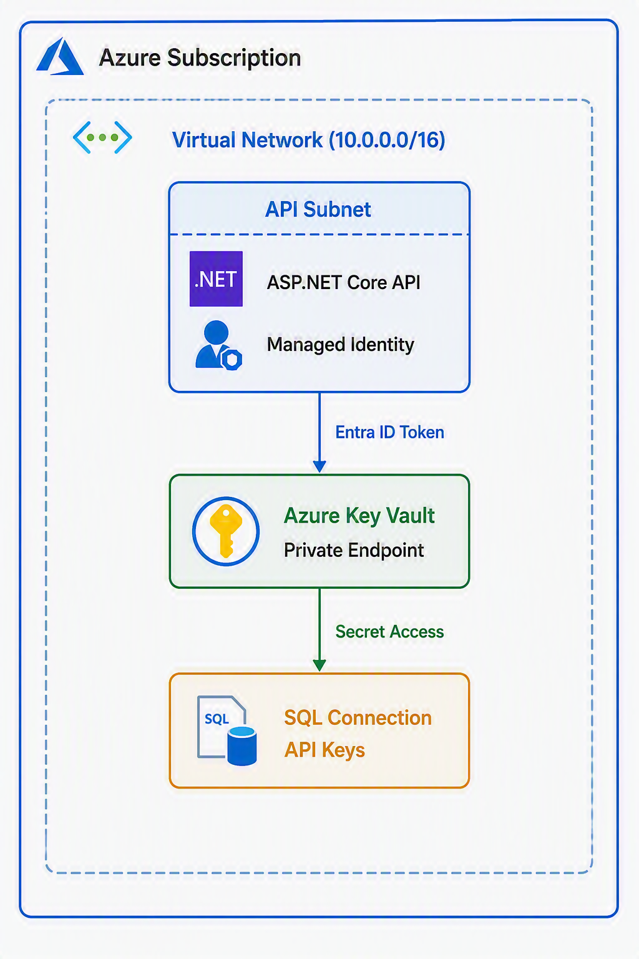

- Store secrets in Key Vault
- Secure APIs using Managed Identity
- Configure VNet + private endpoints

